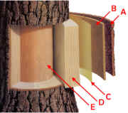 | ------Phloem  ------Bark and bark initials  ------Cambium  ------Sapwood (living xylem)  ------Heartwood (dead xylem)

